**Project Design Phase-II**

**Technology Stack (Architecture & Stack)**

|  |  |
| --- | --- |
| Date | 03 October 2022 |
| Team ID | PNT2022TMID |
| Project Name | Project – Plasma Donor Applications |
| Maximum Marks | 4 Marks |

**Technical Architecture:**

The Deliverable shall include the architectural diagram as below and the information as per the table.

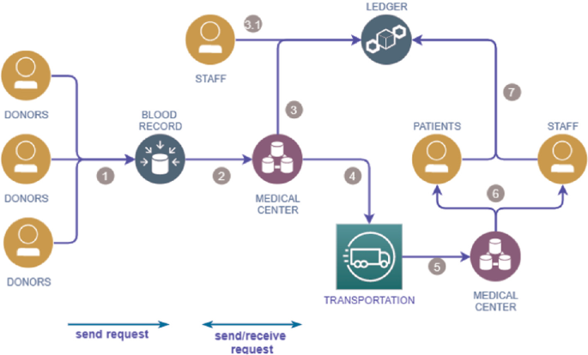

Guidelines:

1. To build a platform with clustering algorithm.
2. Provide a reliable Platform to connect donors with patients.
3. Indicate external applications.
4. Indicate Data Storage components.
5. Indicate cloud web interface for communication purposes.

**Table: Components & Technologies:**

|  |  |  |  |
| --- | --- | --- | --- |
| **S.No** | **Component** | **Description** | **Technology** |
|  | Display page | How user interacts with application | HTML, CSS, JavaScript |
|  | Login | Logic for a process in the application | Java |
|  | Password verification | Verify the password of the user to ensure privacy | IBM Watson Assistant |
|  | Check Data base | Check in the availability of plasma. | IBM Watson Assistant |
|  | Cloud Database | Storing all the informations about the plasma donors and receivers in cloud. | IBM cloud. |
|  | File Storage | Storing all the informations about the plasma donors and receivers in hard-drive. | IBM DB2, IBM Cloud ant |
|  | ID proof verification | Verify the user id to register the plasma donations or receiving applications. | Aadhar API or any other identity |
|  | Cloud Web interface | Using the cloud web interface to provide communications between donor and receivers. | Local, Cloud Foundry, Kubernetes |